Multi-Source Data Integration Pipeline

A Project Report Submitted in
the partial fulfillment of the requirements for the award of the degree of

BACHELOR OF TECHNOLOGY
In

DEPARTMENT OF Computer Science and Engineering
By
K. Sahasra | :2420030068
K. Navya | :2420030180
K. Bhavya Sri | :2420030181

Under the Esteemed Guidance of
Dr N SUNANDA
Associate Professor

Department of Computer Science and Engineering

AY-2026-2027

Semester: Odd Sem




K L (Deemed to be) University DEPARTMENT OF Computer Science and Engineering

Declaration

The Project Report entitled “Multi-Source Data Integration Pipeline” is a record of Bonafide work of K.Sahasra-2420030068, K.Navya-2420030180, and K. Bhavya Sri-2420030181 submitted in partial fulfillment for the award of B. Tech in Computer Science And Engineering to the K L University. The results embodied in this report have not been copied from any other departments/University/Institute.

K. Sahasra – 2420030068
K. Navya – 2420030180
K. Bhavya Sri– 2420030181

K L (Deemed to be) University DEPARTMENT OF Computer Science and Engineering

CERTIFICATE

This is certify that the mini project based report entitled “Multi-Source Data Integration Pipeline” is a bonafide work done and submitted by K.Sahasra-2420030068, K.Navya-2420030180, and K. Bhavya Sri-2420030181 in partial fulfillment of the requirements for the award of the degree of BACHELOR OF TECHNOLOGY in Department of Computer Science and Engineering, K L (Deemed to be University), during the academic year 2026-2027.

_____________________  Signature of the Guide  Dr. N. Sunanda  Associate Professor, CSE | _____________________  Course Coordinator  Dr. N. Sunanda  Department of CSE | _____________________  Head of the Department  Dr. P. Venkateswara Rao  Department of CSE

ACKNOWLEDGEMENT
The success in this project would not have been possible but for the timely help and guidance rendered by many people. Our wish to express my sincere thanks to all those who has assisted us in one way or the other for the completion of my project.

Our greatest appreciation to my Course Coordinator and my guide Dr N Sunanda, Department of Computer Science and Engineering which cannot be expressed in words for his/her tremendous support, encouragement and guidance for this project.

We express our gratitude to Dr. Venkateswara Rao Pulipati, Head of the Department of COMPUTER SCIENCE ENGEERING for providing us with adequate facilities, ways and means by which we are able to complete this project-based Lab.

We thank all the members of teaching and non-teaching staff members, and also who have assisted me directly or indirectly for successful completion of this project. Finally, I sincerely thank my parents, friends and classmates for their kind help and cooperation during my work.

K. Sahasra – 2420030068
K. Navya – 2420030180
K. Bhavya Sri– 2420030181

Abstract

Nowadays, data is collected from various sources such as Excel files, CSV files, MySQL databases, websites, and online applications. Since this data is stored in different formats and structures, combining and analyzing it becomes difficult. Managing data from multiple sources manually also requires more time and effort. The Multi-Source Data Integration Pipeline project aims to solve this problem by collecting and integrating data from different sources into a single system.

In this project, student data is collected from Excel, CSV, MySQL, and REST API sources. The collected data is cleaned and transformed using Python and Pandas. The system handles missing values, removes duplicate records, corrects inconsistent data, and converts different data formats into a common structure. It then integrates the data using a common schema and source-priority rules. The final integrated dataset is stored as a CSV file and can also be loaded into a MySQL database.

The integrated data is used for data analysis, reporting, and visualization. A Streamlit dashboard is used to display the results, while data quality reports and execution logs help monitor the pipeline. Pytest is used for testing and validating the pipeline functionality. This project reduces manual work, improves data quality, and provides a clean and integrated dataset for effective analysis and decision-making.

Index
S. No. | Chapters | Topics | Page.no
 |  | Acknowledgement
 |  | Abstract
1 | Introduction | 1.1 Background of the project  1.2 Problem statement  1.3 Scope of the project  1.4 Objective(s)  1.5 Importance of the application  1.6 Target users/audience | 1-10
2 | System Requirements | 2.1 Hardware requirements  2.2 Software requirements  2.3 Development tools and frameworks | 11-20
3 | Technology Stack | 3.1 Front-end (e.g., React.js, Angular, HTML/CSS)  3.2 Back-end (e.g., Node.js, Django, Spring Boot)  3.3 Database (e.g., MongoDB, MySQL, PostgreSQL)  3.4 Version Control (e.g., Git, GitHub)  3.5 APIs or External services (e.g., Firebase, Stripe) | 21-30
4 | System Architecture | 4.1 High-level architecture diagram  4.2 Description of each layer (frontend, backend, database)  4.3 Deployment architecture (e.g., cloud, local, CI/CD pipelines) | 31-35
5 | Design | 5.1 Wireframes or mockups  5.2 ER Diagram / Database schema | 36-42
6 | Implementation | 6.1 Module-wise implementation  6.2 Front-end logic (UI rendering, state management)  6.3 Backend logic (routes, controllers, business logic)  6.4 Database connectivity  6.5 API integration  6.6 Authentication & Authorization | 43-55
7 | Features | 7.1 List of main features  7.2 How each feature works (user perspective + technical description) | 56-60
8 | Testing | 8.1 Postman testing (frontend/backend)  8.2 Integration testing  8.3 Tools used for testing  8.4 Test cases and results | 61-67
9 | Deployment | 9.1 Steps to deploy  9.2 Environment configuration  9.3 Hosting of frontend and backend | 68-73
10 | Challenges & Limitations | 10.1 Issues faced during development  10.2 Solutions applied  10.3 Current limitations or known bugs | 74-80
11 | Future Enhancements | 11.1 Planned features  11.2 Possible integrations or optimizations | 81-88
12 | Conclusion | 12.1 Summary of the project  12.2 What was achieved  12.3 Skills learned during development | 89-100
13 | References | - Books, tutorials, APIs, documentation sites used
14 | Appendices | - Screenshots of the app  - Sample code snippets  - Installation/setup instructions  - User manual or guide  -certifications

CHAPTER 1
Introduction

1.1 Motivation
Nowadays, data is generated and collected from different sources such as Excel files, CSV files, databases, websites, and online applications. Managing this data separately makes it difficult to combine, organize, and analyze the information effectively. Different sources may contain duplicate records, missing values, and inconsistent data formats, which affect data quality and accuracy.
The main motivation behind the Multi-Source Data Integration Pipeline project is to simplify the process of collecting and managing data from multiple sources. By using Python and Pandas, the project aims to clean, transform, and integrate data into a common format. This reduces manual work, saves time, and helps users access reliable and organized data for further analysis and decision-making.
1.2 Objective
The main objective of the Multi-Source Data Integration Pipeline is to develop a system that collects data from different sources and combines it into a single integrated dataset. The project focuses on improving data quality and making data management easier and more efficient.
The system aims to collect student data from Excel files, CSV files, MySQL databases, and REST APIs. It performs data cleaning by handling missing values, removing duplicate records, and correcting inconsistent information. It also transforms the collected data into a common format and integrates it using a common schema and source-priority rules.
The final integrated data is stored in a CSV file and can optionally be loaded into a MySQL database. The project also supports data analysis and visualization through a Streamlit dashboard and uses Pytest for testing and validation.
1.3 What is Data Integration?
Data Integration is the process of collecting and combining data from different sources into a single, unified system. Data may come from different formats such as Excel files, CSV files, databases, websites, and online applications.
The main purpose of data integration is to make information from different sources available in a common format. It helps to identify duplicate records, handle inconsistent information, and improve the overall quality of data.
Data integration makes it easier to manage, access, and analyze information. It is useful for generating reports, creating visualizations, and supporting better decision-making.
1.4 What is a Data Pipeline?
A Data Pipeline is a sequence of steps used to collect, process, transform, and store data from different sources. It helps move data from its original location to a final destination in an organized manner.
A typical data pipeline consists of data collection, data cleaning, data transformation, data integration, and data storage. Each step prepares the data for the next stage and helps maintain data quality.
In our project, the data pipeline collects student records from Excel, CSV, MySQL, and REST API sources. The collected data is cleaned and transformed using Python and Pandas before being integrated into a single dataset. This makes the data ready for analysis and visualization.
1.5 What is ETL?
ETL stands for Extract, Transform, and Load. It is a process used to collect data from different sources, convert it into a suitable format, and store it in a destination system.
The three main stages of ETL are:
1. Extract: Data is collected from different sources such as Excel files, CSV files, MySQL databases, and REST APIs.
2. Transform: The collected data is cleaned and processed by handling missing values, removing duplicate records, correcting inconsistent data, and converting it into a common format.
3. Load: The cleaned and transformed data is stored in a destination such as a CSV file or MySQL database.
In our Multi-Source Data Integration Pipeline project, the ETL process helps combine data from multiple sources into one clean and integrated dataset. This makes the data easier to manage, analyze, and use for reporting and visualization.

CHAPTER 2
Software Requirement

2.1 Problem Statement
Nowadays, data is collected from different sources such as Excel files, CSV files, MySQL databases, websites, and online applications. The main problem is that these sources store data in different formats and structures, making it difficult to combine and analyze the information effectively.
Data collected from multiple sources may contain missing values, duplicate records, and inconsistent information. Cleaning and combining this data manually requires more time and effort. Existing approaches may handle different parts of the data integration process, but managing the complete process in one system is still challenging.
The Multi-Source Data Integration Pipeline project aims to solve this problem by developing a pipeline that collects data from multiple sources, cleans and transforms it into a common format, and integrates it into a single database. This helps improve data quality, reduce manual work, and make the integrated data useful for reporting, visualization, and decision-making.
2.2 Technologies Used
1. Python:
Python is a high-level, interpreted programming language used for developing applications, data analysis, and automation. It provides simple syntax and various libraries that make data processing easier. In our project, Python is used as the main programming language to develop the ETL pipeline. It helps collect, clean, transform, and integrate data from multiple sources.
2. Pandas:
Pandas is an open-source Python library used for data manipulation and analysis. It provides data structures such as Series and DataFrame to handle structured data efficiently. It supports reading data from Excel and CSV files, handling missing values, removing duplicate records, and transforming data into a common format. In our project, Pandas is mainly used for data cleaning, transformation, and integration.
3. MySQL:
MySQL is an open-source relational database management system used to store and manage structured data. It organizes information into tables consisting of rows and columns. MySQL supports operations such as inserting, updating, retrieving, and managing records. In our project, MySQL is used as a source for collecting student records and can also be used as an optional destination for storing the final integrated dataset.
4. Excel:
Microsoft Excel is a spreadsheet application used to organize, store, and manage data in rows and columns. It supports calculations, sorting, filtering, and data analysis. Excel files are commonly used for storing structured information. In our project, Excel is used as one of the input sources for collecting student data.
5. CSV (Comma-Separated Values):
CSV is a simple file format used to store tabular data in plain text. Each row represents a record, and individual values are separated by commas. CSV files are easy to create, read, and transfer between different applications. In our project, CSV is used as an input source and also as the final output format for storing the integrated dataset.
6. REST API:
REST API stands for Representational State Transfer Application Programming Interface. It allows different applications to communicate and exchange data over the internet using HTTP requests. REST APIs commonly transfer data in JSON format. In our project, REST API is used to collect student data from external sources and include it in the integration pipeline.
7. Requests:
Requests is a Python library used to send HTTP requests and communicate with web services. It makes it easier to access REST APIs and retrieve data from external sources. In our project, the Requests library is used to send API requests and fetch student records for the data integration process.
8. Streamlit:
Streamlit is an open-source Python framework used to create interactive web applications and dashboards for data analysis and visualization. It allows developers to display data using charts, tables, and other visual elements. In our project, Streamlit is used to develop an interactive dashboard to display integrated data and data quality results.
9. Pytest:
Pytest is a Python testing framework used to write and execute automated test cases. It helps identify errors and verify whether different parts of a program work correctly. In our project, Pytest is used to test the pipeline functionality and validate the reliability of the data processing operations.

CHAPTER 3
Software Design

3.1 DFD
A Data Flow Diagram (DFD) is a graphical representation of how data moves through a system. It explains how data enters the system, how it is processed, and how the final output is generated. A DFD helps to understand the flow of information between different sources, processes, and destinations.
In our Multi-Source Data Integration Pipeline project, the DFD represents how student data is collected from multiple sources such as Excel files, CSV files, MySQL databases, and REST APIs. The collected data is processed using Python and Pandas to handle missing values, remove duplicate records, and correct inconsistent information.
After cleaning and transformation, the data from different sources is integrated into a common format and stored as a final CSV file. The integrated data can also be loaded into a MySQL database. Finally, the system generates data quality reports and displays the results through a Streamlit dashboard.
The DFD helps explain the complete flow of data from collection to integration and final output.
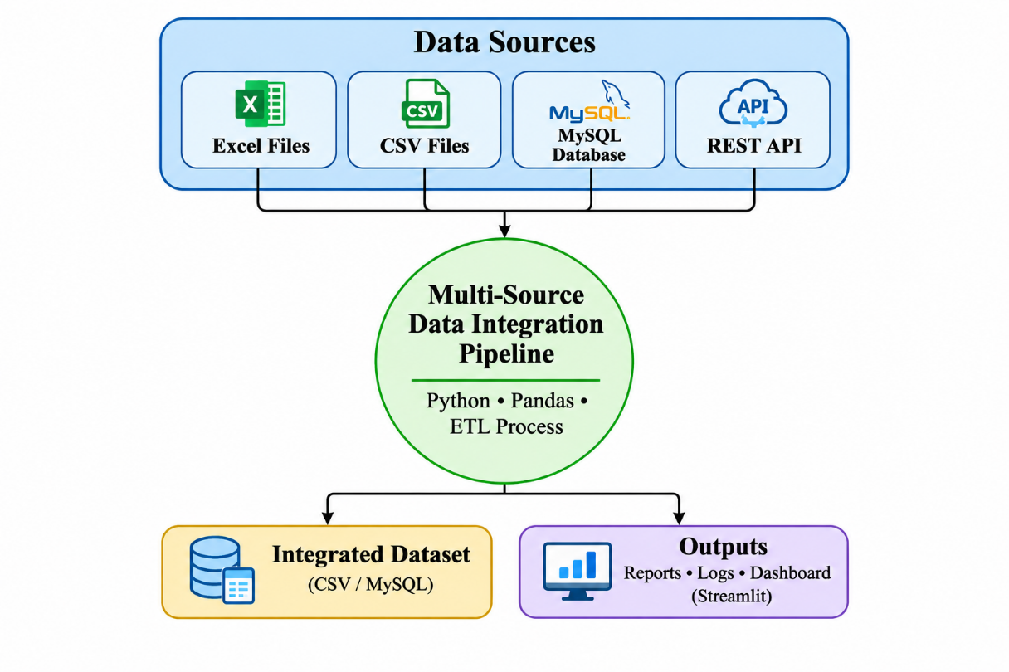
Fig No. 3.1 DFD LEVEL-0

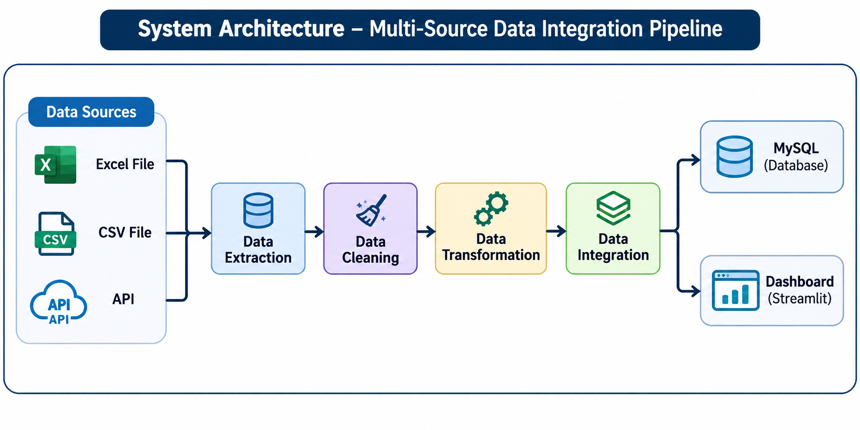

CHAPTER 4
Implementation and User Interface

4.1 Application Page Details
The Multi-Source Data Integration Pipeline consists of different modules that help users collect, process, integrate, and visualize data from multiple sources. The main modules of the application are:
- Home Page / Dashboard
- Data Source Selection
- Data Collection
- Data Cleaning and Transformation
- Data Integration
- Integrated Dataset
- Data Quality Reports
4.2 Detailed Description of Pages
1. Home Page / Dashboard:
The Home Page is the main interface of the application. It provides an overview of the Multi-Source Data Integration Pipeline and displays the available data sources and important information about the integration process. Users can access the different functionalities of the system through the dashboard.
2. Data Source Selection:
This module allows users to work with different data sources such as Excel files, CSV files, MySQL databases, and REST APIs. It provides the required input data for the integration pipeline. These different sources help collect student records from multiple locations.
3. Data Collection Page:
The Data Collection module is responsible for extracting data from the selected sources. It retrieves records from Excel, CSV, MySQL, and REST API sources. The collected information is passed to the next stage for data processing.
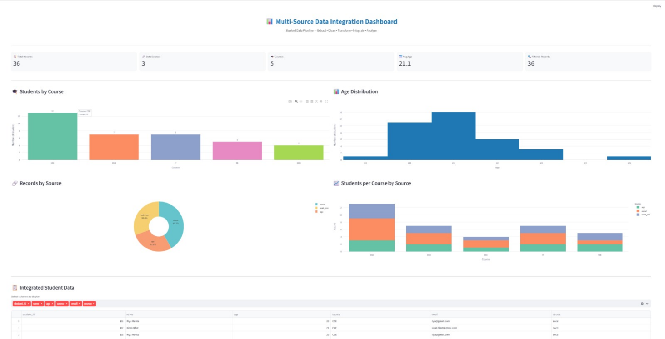
4. Data Cleaning and Transformation Page:
This module performs data cleaning and transformation using Python and Pandas. It handles missing values, removes duplicate records, and corrects inconsistent information. The collected data is converted into a common format so that records from different sources can be integrated properly.
5. Data Integration Page:
The Data Integration module combines the cleaned and transformed data from different sources into a single dataset. It uses a common schema and source-priority rules to maintain consistency and avoid duplicate records. This module produces a unified dataset for further analysis.
6. Integrated Dataset Page:
This module displays the final integrated dataset generated by the pipeline. The processed data is stored in CSV format and can optionally be loaded into a MySQL database. Users can access the organized records for further analysis and reporting.
7. Data Quality Reports and Dashboard:
The Data Quality Reports module provides information about the quality of the integrated data. It helps monitor missing values, duplicate records, and other data-related issues. The Streamlit dashboard displays the processed results in an interactive manner. Execution logs are also used to monitor the pipeline activities.
8. Testing and Validation:
The system uses Pytest to test and validate the functionality of the data integration pipeline. It helps identify errors and ensures that the data processing operations work as expected.

CHAPTER 5

Conclusion and Future Aspects

5.1 Conclusion
We have successfully developed the Multi-Source Data Integration Pipeline, which helps collect and integrate data from multiple sources such as Excel files, CSV files, MySQL databases, and REST APIs. With the help of Python and Pandas, we have successfully performed data cleaning, transformation, and integration to generate a single unified dataset.
The system helps handle missing values, remove duplicate records, and maintain consistency among data collected from different sources. The integrated data is stored in CSV format and can optionally be loaded into a MySQL database. The Streamlit dashboard provides an interactive way to view the results, while data quality reports and Pytest validation help monitor and verify the pipeline functionality.
Finally, this project reduces manual effort, saves time, improves data quality, and makes the integrated information easier to access and analyze. The developed pipeline provides a useful solution for managing data from multiple sources efficiently.
5.2 Future Aspects
- We can integrate additional data sources such as cloud storage platforms and other databases.
- We can automate the pipeline to collect and update data at regular intervals without manual execution.
- We can improve the Streamlit dashboard by adding more interactive charts, filters, and detailed data analysis.
- We can implement real-time data integration to process continuously incoming data from different sources.
- We can add advanced data validation techniques to identify incorrect, incomplete, and inconsistent records more accurately.
- We can deploy the application on cloud platforms so that users can access the data integration system from anywhere.
CHAPTER 6
Bibliography

- Python Official Documentation:
https://docs.python.org/3/
- Pandas Official Documentation:
https://pandas.pydata.org/docs/
- MySQL Official Documentation:
https://dev.mysql.com/doc/
- Streamlit Official Documentation:
https://docs.streamlit.io/
- Requests Library Documentation:
https://requests.readthedocs.io/
- Pytest Official Documentation:
https://docs.pytest.org/
- Git Official Documentation:
https://git-scm.com/doc
- Jupyter Notebook Documentation:
https://docs.jupyter.org/
- REST API Documentation:
https://restfulapi.net/

CHAPTER 7

Appendices

7.1 APP.py
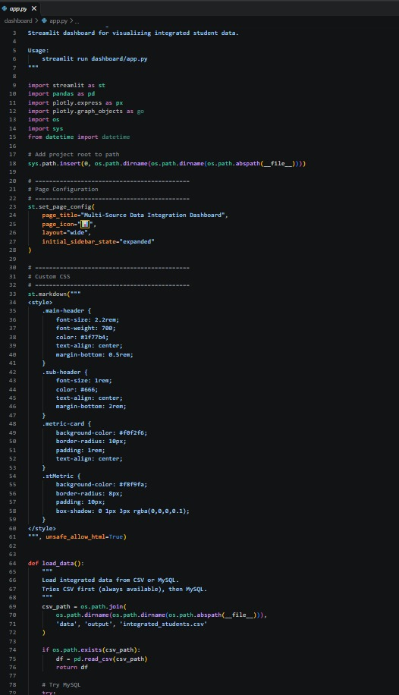

7.2 DATASETS
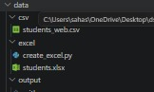
7.3 PIPELINE.PY
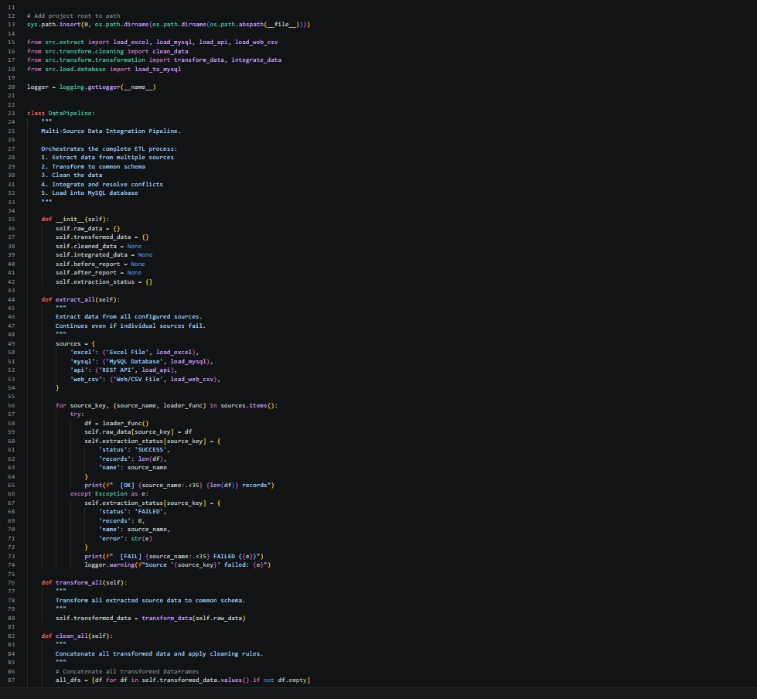

7.4 TEST CLEANING.py
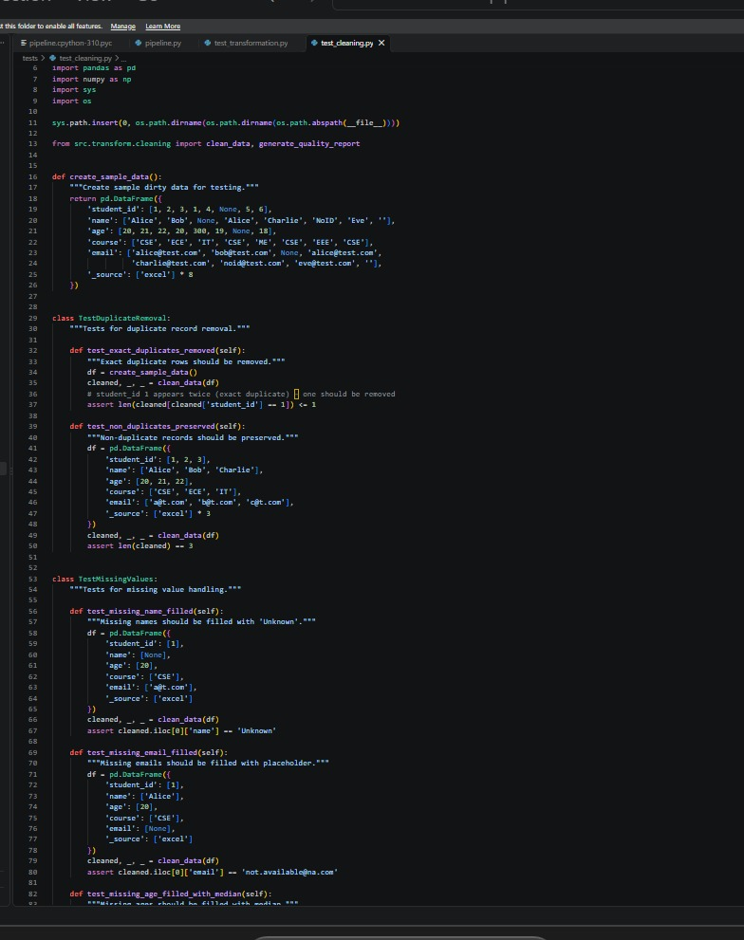

7.5 TESTPIPELINE.PY
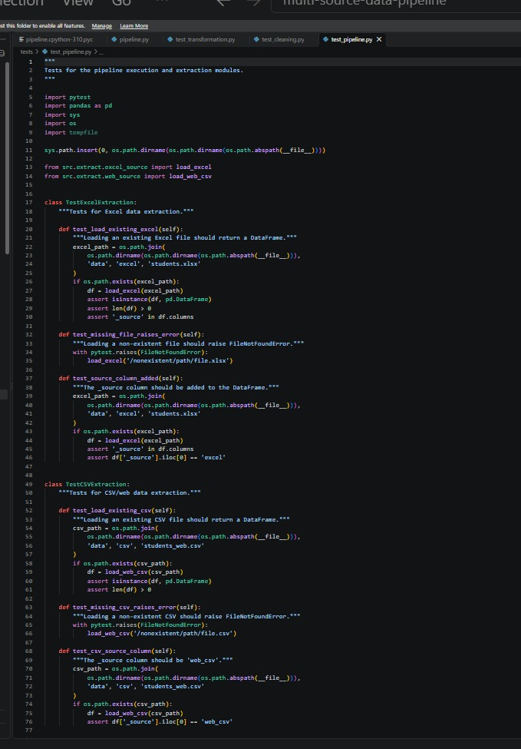
7.6 PIPELINE.LOGS
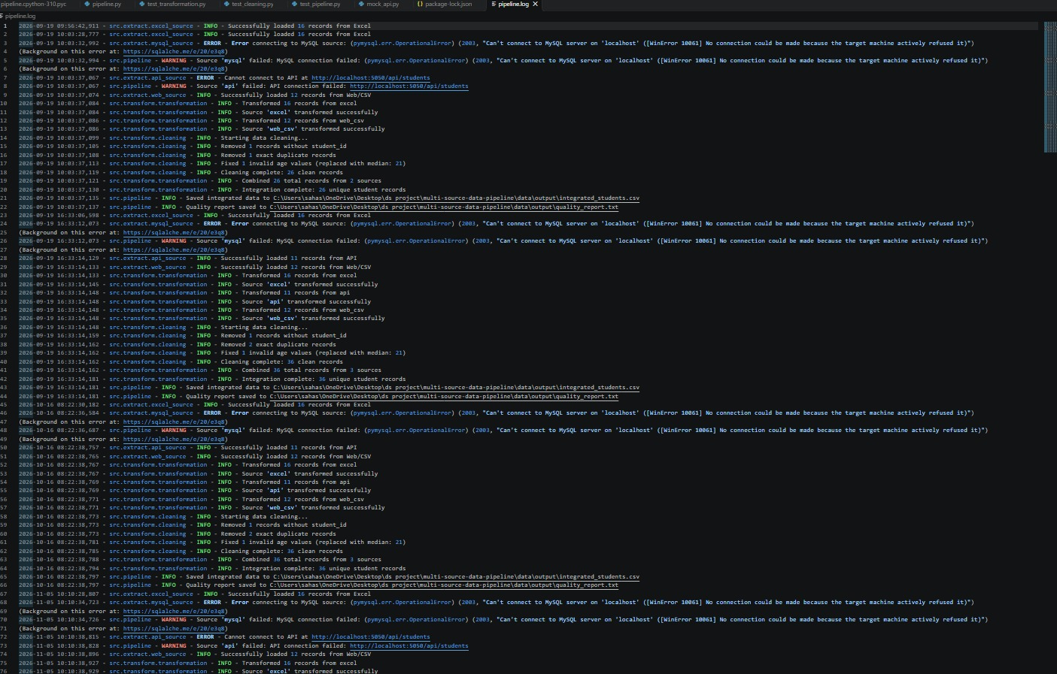
7.7 REQURIEMENTS TXT
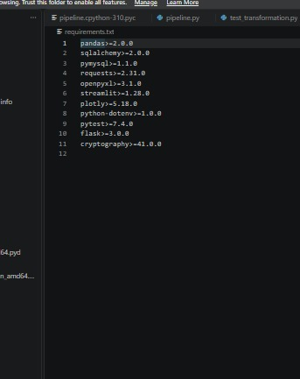

7.8 RUNPIPELINE.PY


